**Ideation Phase**

**Define the Problem Statements**

|  |  |
| --- | --- |
| Date | 27 September 2022 |
| Team ID | PNT2022TMID50914 |
| Project Name | EFFICIENT WATER QUALITY ANALYSIS AND PREDICTION USING MACHINE LEARNING |
| Maximum Marks | 2 Marks |

**Problem Statement 1:**

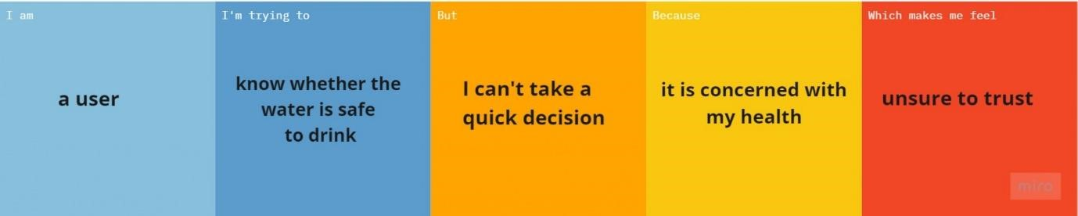

**Problem Statement 2:**

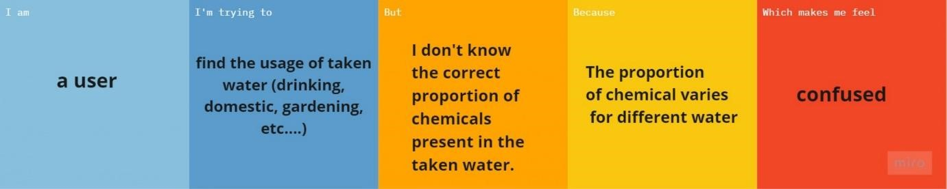

**Reference Link:**

https://miro.com/welcome/Zm44YW81ZnJVeTF4OERkdEM3dmVGRGtDYkpqT3VTOHhWMz

Nqa0FKZXBKT25id0VyRUlVSWo3bTEzbkh6ZzY1OXwzNDU4NzY0NTM0NTM5OTQ3NjYxfG4vY Q==?share_link_id=658844822579